Assignment (Day - 1)

# Multiple Choice Questions:

Q1. What output does the following code snippet produce?

**print(8, 5, 2023, sep='/')**

A1. **8/5/2023**

Q2. Which of the following is considered a valid variable name in Python?

A2. **_my_string**

Q3. After executing x = 3.5, what data type is x?

A3. **float**

# Fill in the Blanks:

Q4. In Python, the ________ function is utilised to convert a floating-point number to an integer.

A4. **int()**

Q5. The ________ parameter in the print() function dictates what is printed at the end of the output.

A5. **end=’’**

Q6. A ________ type in Python can hold one of two values: True or False.

A6. **Bool**

# True or False:

Q7. Variable names in Python are case-sensitive.

A7. **True**

Q8. The print() function is limited to printing strings exclusively.

A8. **False**

Q9. In Python, the string "100" is equivalent to the integer 100.

A9. **False**

# Coding Challenge:

Q11.Develop a Python script to calculate the area of a rectangle. Your program should take the rectangle's length and width, and then display the calculated area.

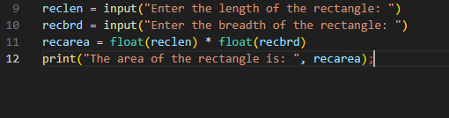A11. Please follow the code below:

Q12. Write a Python program that converts temperatures from Celsius to Fahrenheit. Use the formula (Celsius * 9/5) + 32 to perform the conversion.

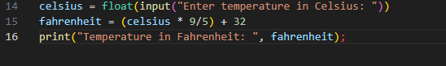A12. Please follow the code below: